Creating a Cart Service
In this exercise, you will
- Create a shopping cart service
- Learn different techniques to inject the service (Dependency Injection)

- Continue from previous store application. Make sure that the Terminal Server is there. Run the web project.
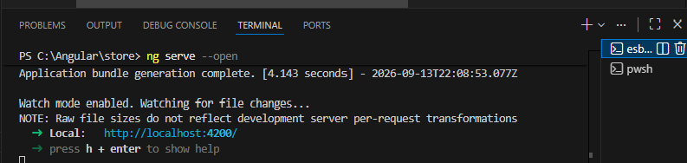

- To create a new cart service, run the command ng g s cart/cart-service in terminal
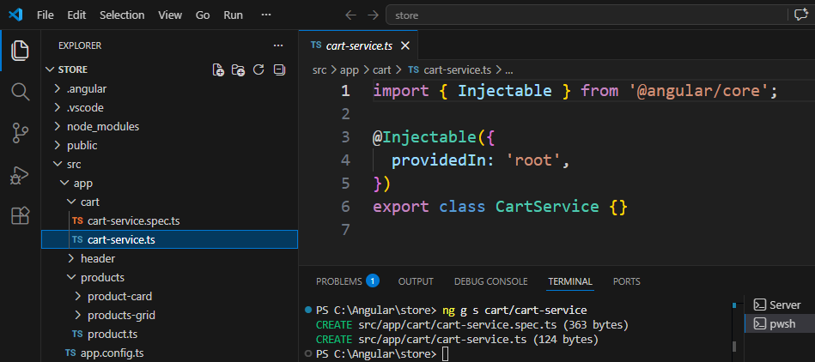
Note: This service was created as Singleton.
- In the cart-service constructor, add the following codes:
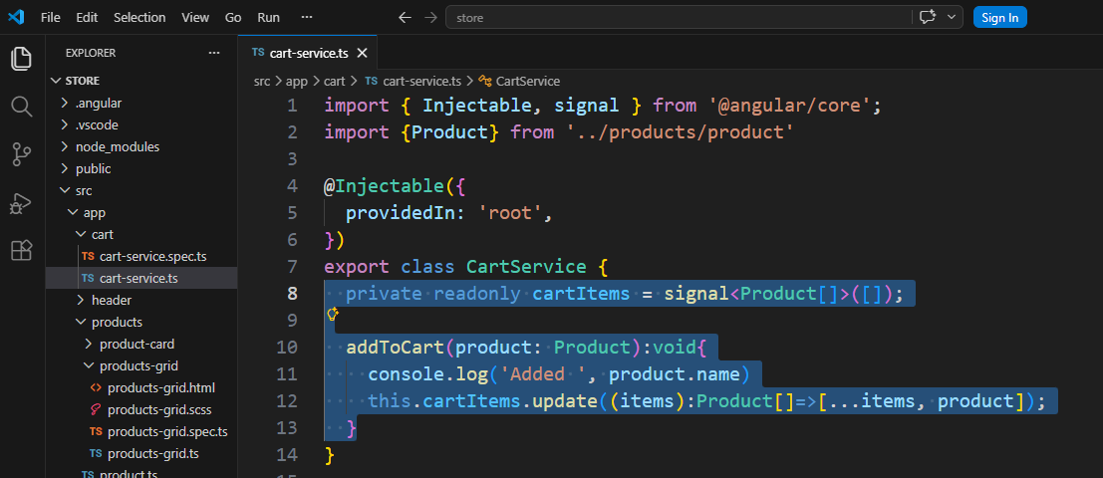
- Next, we need to inject this service into products-grids Component. In products-grid.ts, add and make few changes as below
import { Component, signal, computed, inject } from '@angular/core';
import { ProductCard } from '../product-card/product-card';
import { Product } from '../product';
import {MatIconModule} from '@angular/material/icon';

import {FormsModule} from '@angular/forms';
import {MatInputModule} from '@angular/material/input';
import {MatFormFieldModule} from '@angular/material/form-field';
import { CartService } from '../../cart/cart-service';

@Component({
selector: 'app-products-grid',
imports: [ProductCard, MatIconModule, MatFormFieldModule, MatInputModule, FormsModule, MatIconModule],
templateUrl: './products-grid.html',
styleUrl: './products-grid.scss',
})
export class ProductsGrid {
protected readonly searchTerm = signal('');

//Method #1: Inject via constructor
//private cartService:CartService;
//ProductsGrid(cartService: CartService){
// this.cartService = cartService;
//}

//Mthod #2: Inject using inject function
private readonly cartService:CartService = inject(CartService);

protected readonly products = signal<Product[]>([
{
id: 1,
name: "Durian",
description: "The king of fruit",
price: 35.0,
originalPrice: 50.0,
},
{
id: 2,
name: "Nenas",
description: "Unique fruit from Johor",
price: 8.0,
},
{
id: 3,
name: "Dokong",
description: "Imported fruit from Thailand",
price: 12.0,
}
]
);

protected readonly filteredProducts = computed(()=>{
const term = this.searchTerm().toLocaleLowerCase().trim();
if(!term) return this.products();
return this.products().filter(p=>p.name.toLocaleLowerCase().includes(term)||
p.description.toLocaleLowerCase().includes(term));
})
protected clearSearch():void{
this.searchTerm.set('');
}

protected trimSearch(): void{
this.searchTerm.update(v=>v.trim())
}

protected handleSelection(product: Product) {
this.cartService.addToCart(product);
}
}

- In the web browser, press F12, select “Console”
- Try Add Durian and Nenas
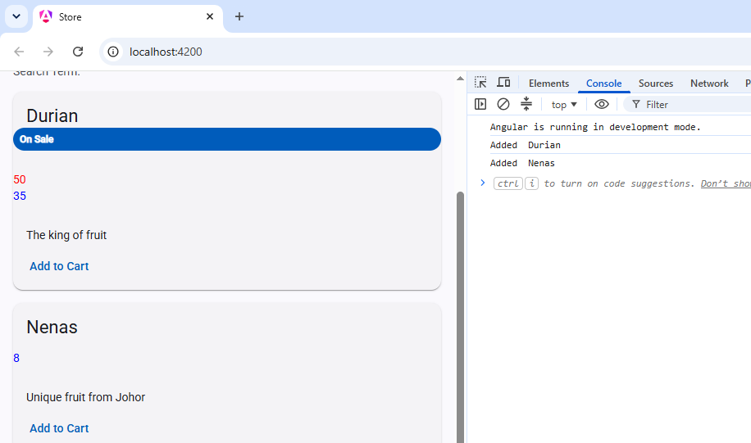
- Close VS Code

- Backup/Zip the application as store(Ex16).7z

